Hello,
there are two elementary schools in Blatna. Our school´s name is T. G. Masaryka. Our school is near the park and near the railway station.
There are 361 pupils and 28 teachers in our school this year. There are 15 classes. We learn Maths, Czech, English, German, Science, History, Geography and other subjects.
There is a school council in our school, too. We are members of the school council. Our school council organizes projects for our classmates and for people in Blatna. We won in a national competition of charity projects. We like to work in a school council – it´s fun!!!

Vojta and Adam, members of the school council
OUR SCHOOL COUNCIL TEAM
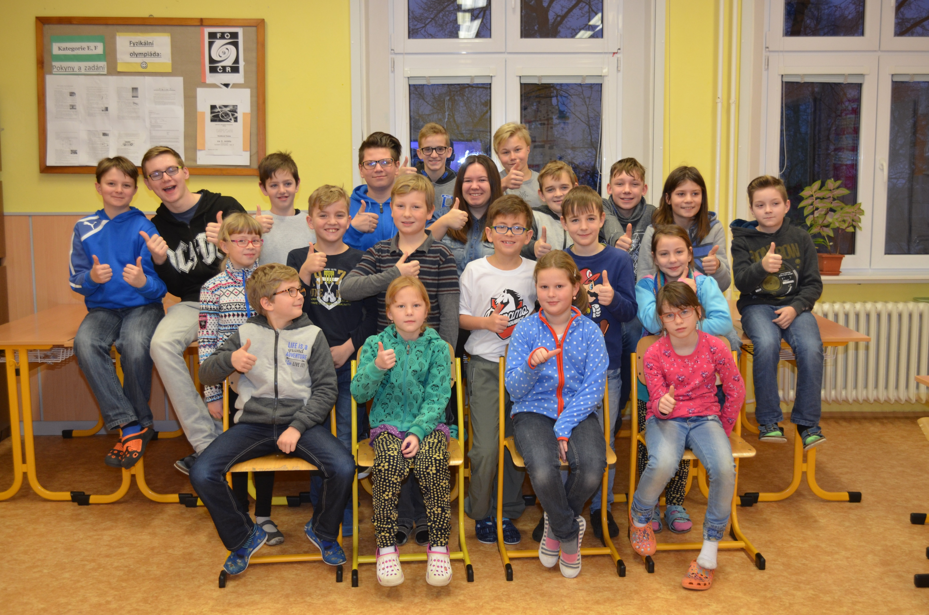
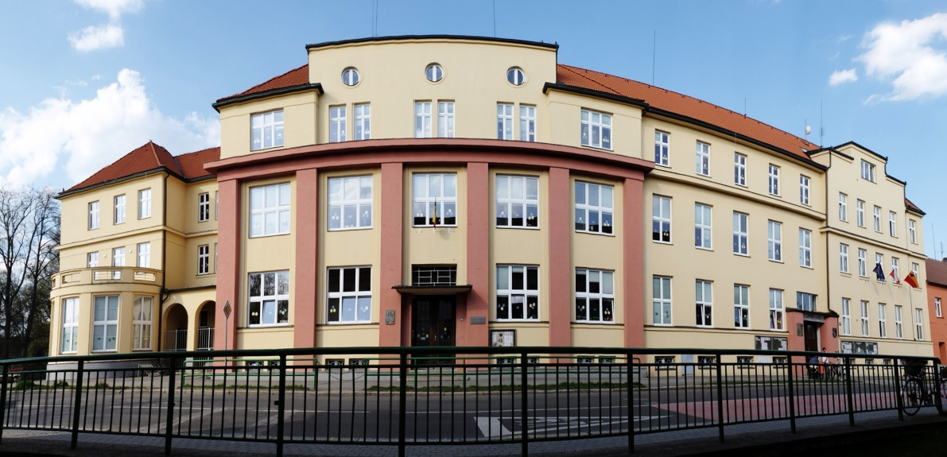
OUR SCHOOL

